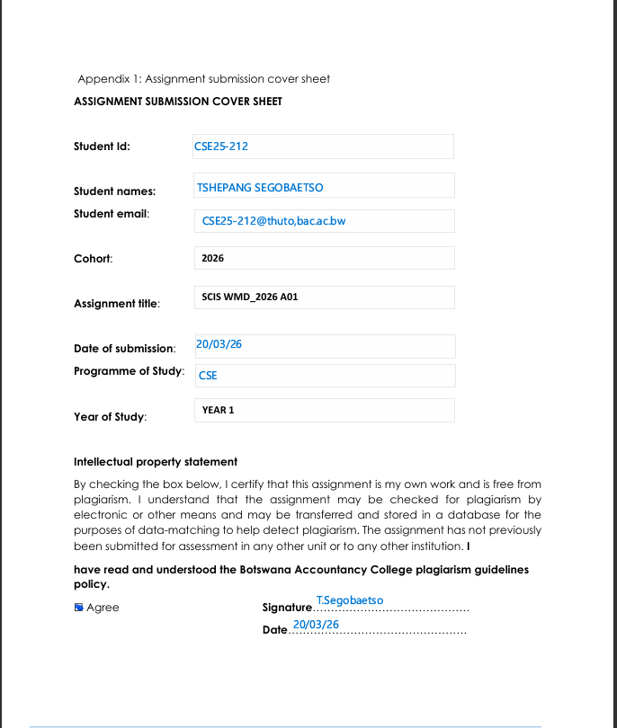

WEBSITE SPECIFICATION

Website Objective and Goals

I really wanted to overhaul the Aptec Computers web design. The goal wasn't just a face-lift; I needed a site that is fast, modern, and actually easy for people to navigate. I have a lot of great hardware and accessories, but the old setup made it too hard for customers to find what they needed. This new version changes that.

The redesign is focused on a few core improvements:
- Cleaning up the layout so it is not a maze for the user.
- Making sure the pages load fast and look right on a phone.
- Cutting out the extra fluff to keep the content organized.
- Putting the "buy" buttons and contact info right where people expect to see them.

I have added a few interactive bits to keep things moving. There is a proper navigation menu, deep dives on the product pages, a working shopping cart, and a way for users to send us feedback. It is all about making the visit feel like a smooth experience rather than a chore for the customer.

At the end of the day, I just want a site that works better and is easier to deal with than the OLD one .

GOALS
- Drive more sales for our computers and parts by giving them a better home online.
- Look like a professional shop so people actually trust them with their money.
- Give people the facts about our products without making them hunt for it.
- Make it simple to find company contacts or ask for a repair quote.
- Nail the shopping experience by using a familiar cart and checkout flow.

Target Audience

Demographics
- Age: Anyone from 18 to 50.
- Gender: Both men and women.
- Location: People living in cities and towns all over Botswana.
- Groups: Students, people running small businesses, and general home users.

Technical Aptitude
I did not want to build something only IT pros could use. It had to work for everyone, regardless of their tech skills.

For beginners:
For the people who just want to do the basics, like checking a price or sending a message, I kept the labels simple. The instructions are clear so they do not feel lost.

For intermediate users:
For people who like to compare a few different laptops before they pull the trigger, I organized the data so they can find the details they need to make a solid choice.

For advanced users:
And for the IT students or pros who want the raw power, I did not skimp on the details. The full hardware specs are all there for every piece of gear we sell.

Type of Website / Content

The site is a bit of a hybrid—part information hub for the business and part basic e-commerce shop.

This is what is included:
- Full lists of our laptops, desktops, and various parts.
- The latest pricing and technical specs for everything in stock.
- A clear guide on how we handle computer repairs and maintenance.
- A cart system so users can practice the shopping process.
- The direct phone number, email, and a feedback form.
- A bit of history on the shop on the "About" page.

INFORMATION DESIGN & TAXONOMY

Information Design
I did not want people hunting for links. Everything is grouped where it makes the most sense so you can find what you need in a couple of clicks.

Every page uses the same basic skeleton:
- A header at the top with the main menu.
- The middle section for the actual page info.
- A footer at the very bottom for the extra links.

SITE MAP
This hierarchical structure layout makes sure all the pages are connected properly. I checked for broken links so you can move around the site without running into any dead ends.
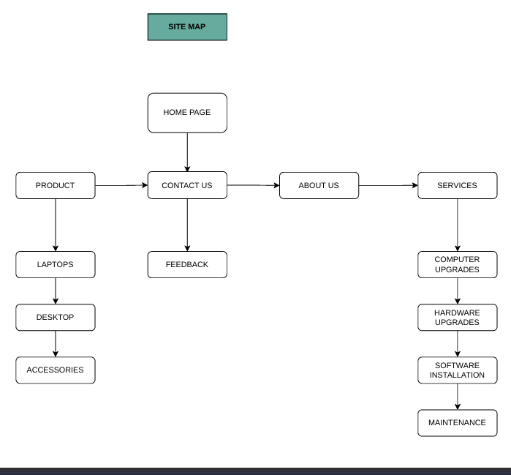

WIREFRAME

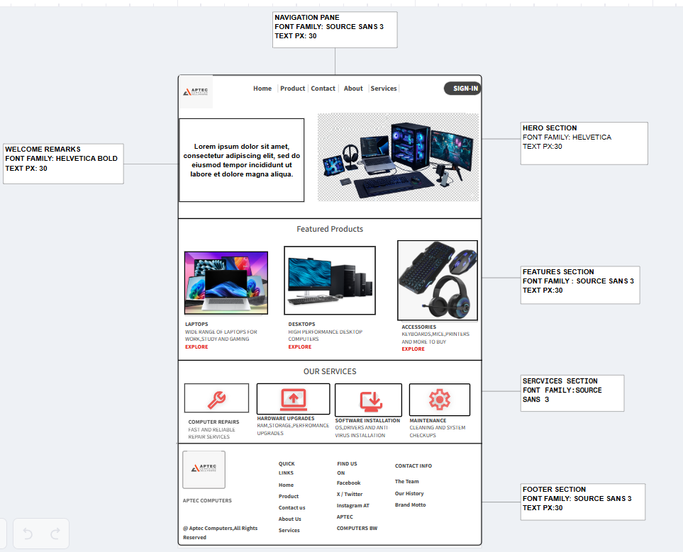

PRODUCT PAGE

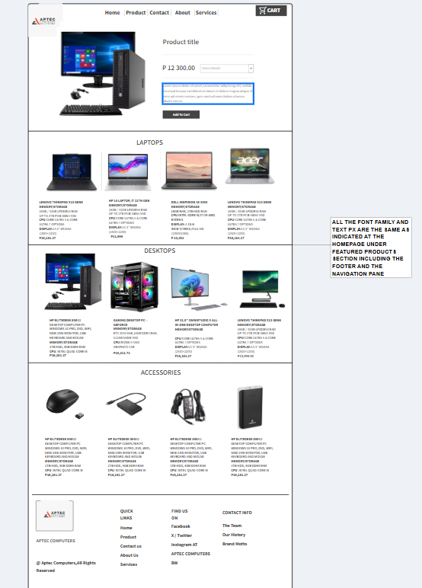

TECHNICAL BRIEF
Technologies Used
- HTML5: This is the skeleton that holds all the content together.
- CSS3: I used this for the colours and making sure the site scales for mobile.
- JavaScript: This handles the moving parts, like how the menu drops down and how the forms work.

Software Tools
- Google Chrome: This is the main window for testing
- Visual Studio Code (VS Code): The primary tool where all the code was written.
- GitHub: I used this to track our code changes and host the site through GitHub Pages.
- Canva / Photoshop / GIMP: These were used to make the graphics and edit the product photos.
- Figma / Adobe XD/Mock flow: I used these to sketch out the look and feel before I started coding.

Justification of Tools
I went with these tools because they are the industry standard for a reason. They allow the user to build a site that won't break on a weird screen size and keeps the development process moving fast. They also helped create a final product that is actually easy for our customers in Botswana to use.

QUALITY ASSURANCE
WEBSITE LAYOUT ON MICROSOFT EDGE

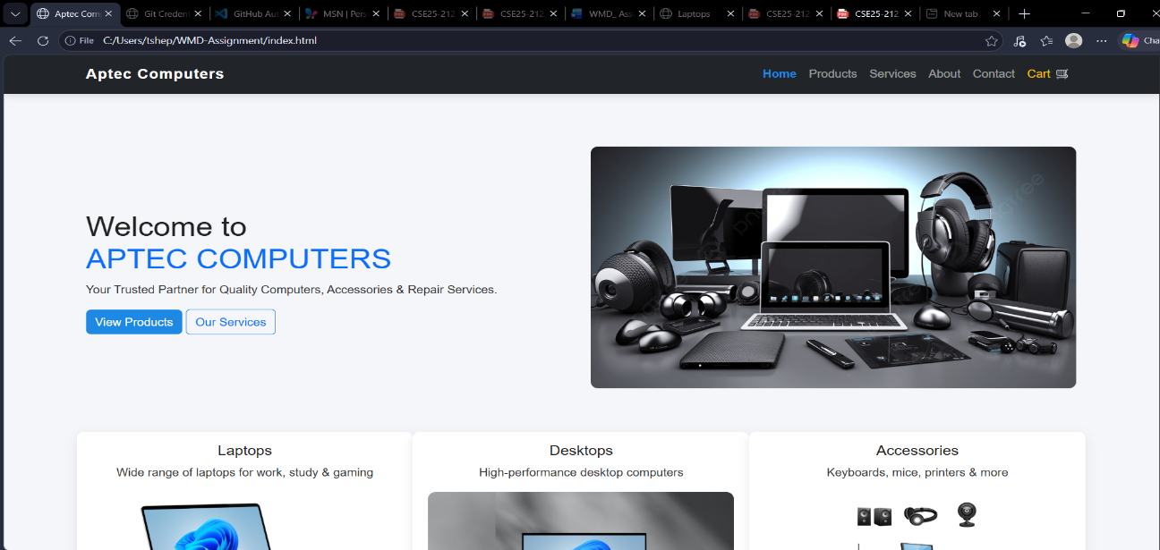

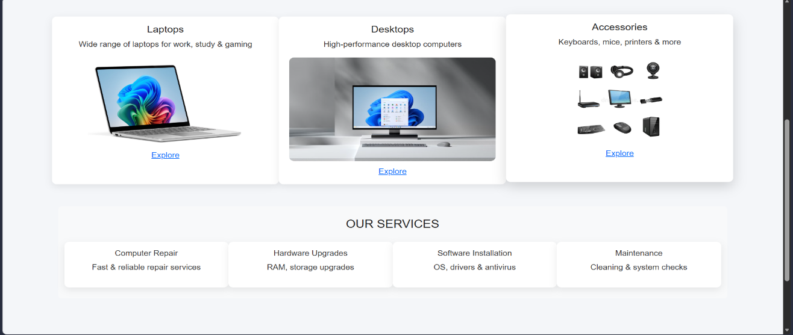


WEBSITE LAYOUT ON CHROME

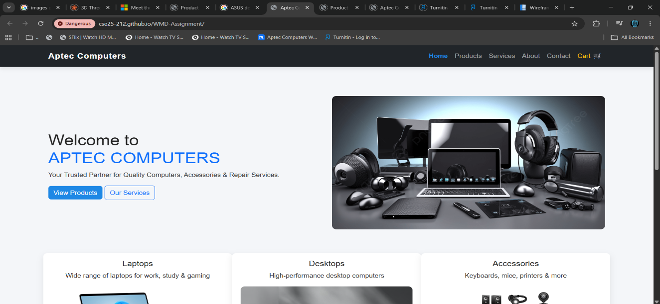

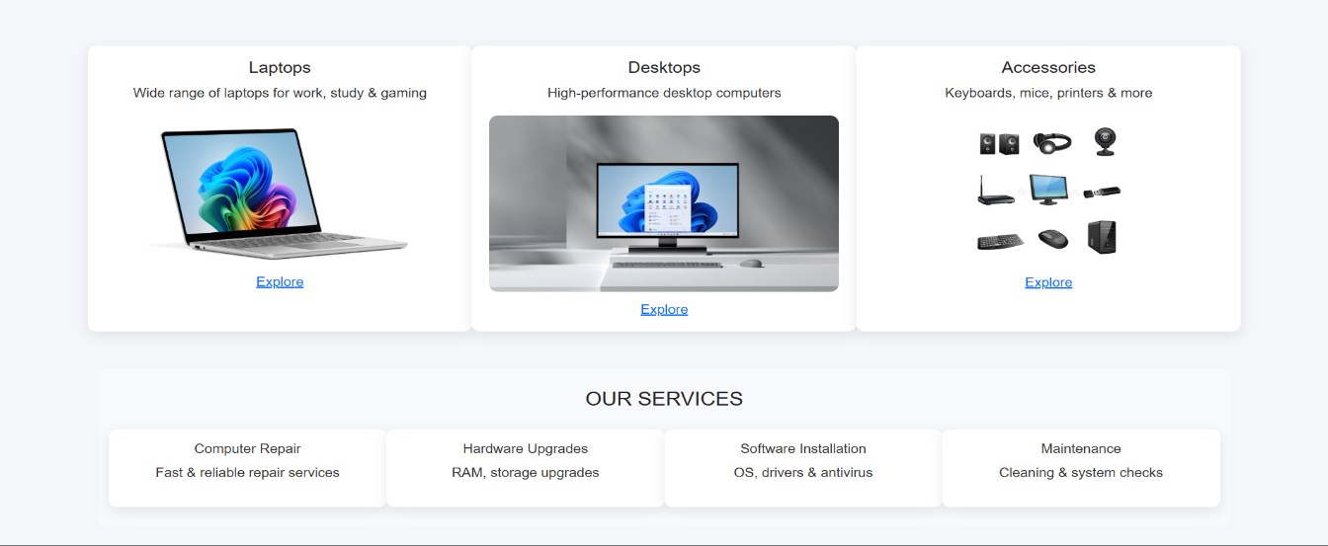



MOBILE LAYOUT

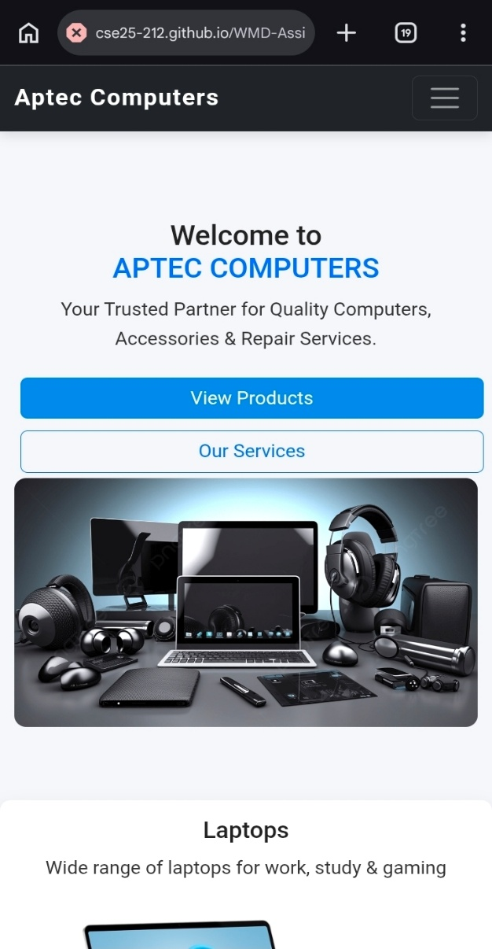

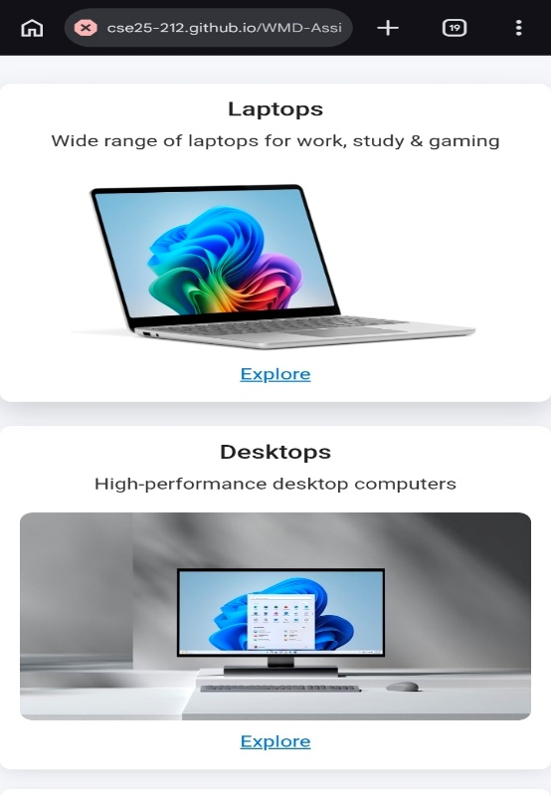

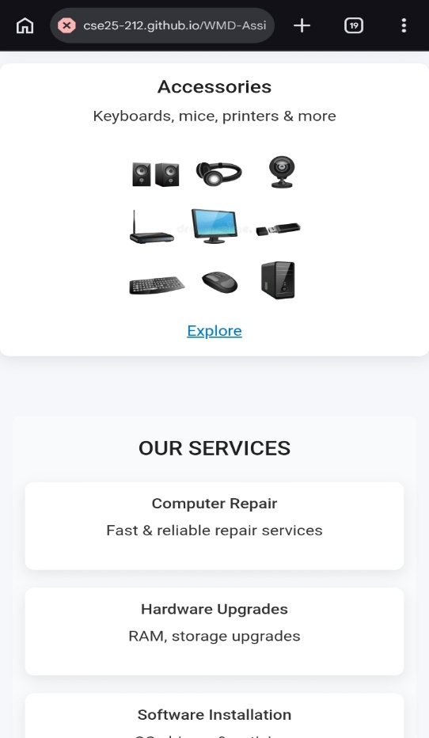

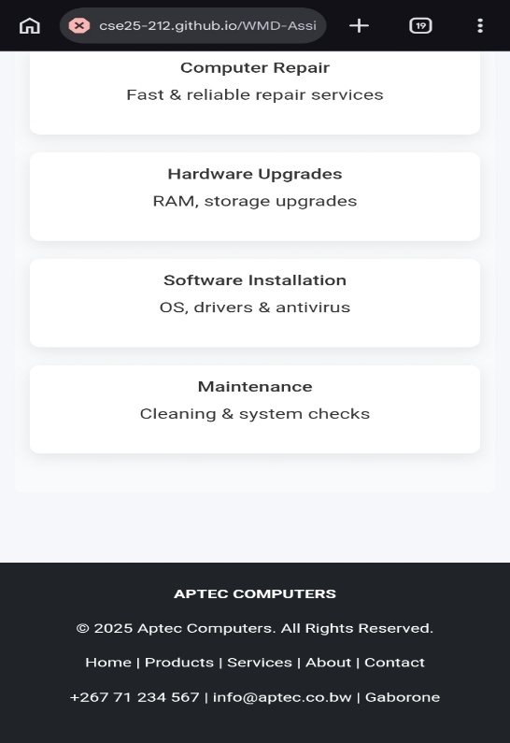

PUBLISHING AND PROMOTION

Publishing and promotion

I host the Aptec Computers website on GitHub Pages, a free service from GitHub. I went with this because it’s reliable and works well for static sites built with HTML, CSS, and JavaScript.

Tools I used
VS Code — to write and edit the code
Git — for version control and tracking changes
GitHub — to store the project repository online
GitHub Pages — for hosting and publishing the site

Methods for hosting the website

1. Making the repository

I started by creating a new GitHub repository to hold all the website files, including the code, scripts, and images.

2. Pushing files with Git

I used the terminal in VS Code to run several Git commands to get the files online:

git init
git add .
git commit -m "Initial website upload"
git branch -M main
git remote add origin https://github.com/your-username/aptec-website.git
git push -u origin main

These commands start the project, track the files, save the progress, and send everything to the GitHub repository.

3. Going live with GitHub Pages

Once the files were uploaded, I did this:
I opened the repository settings
I went to the Pages section
I set the source to the main branch
The site was then published automatically

REPORT

Website Planning and Documentation

Introduction
This report breaks down how I planned and built the site for this brand. I wanted a place where users could actually find product info, jump between pages without a headache, and talk back to us via a feedback form. I used the standard HTML5, CSS3, and JavaScript combo and made sure everything followed W3C rules so the code is clean and the site actually works.
Purpose of the website
The main reason for this project was to give the brand a real home online. I wanted a clean interface that did not feel cluttered or confusing. People should be able to jump between pages without thinking about it. Plus, I included a feedback form for actual interaction and a cart page to show what a real online shop feels like.

Target audience

I thought about three types of people when I was designing this. First, the casual browsers who are just curious. Then, the serious shoppers who want a no-nonsense way to see what is for sale. Since everyone is on their phones these days, I made sure the site works just as well on a mobile screen as it does on a desktop. The design is simple and responsive so it is easy to use for everyone, no matter their tech level.

Website Features

The site has a few core features that make it tick. It uses a solid HTML5 structure and CSS3 for the layout. I added JavaScript to handle the interactive bits like the cart and the form logic. It is fully responsive, so it shifts to fit mobile screens perfectly. There is a navigation bar that stays the same on every page, a dedicated product display area, a working cart, and a feedback form. I kept the layout uniform across the board so the whole site feels like one cohesive project.

Site map Structure

The structure is very straightforward to keep the user experience simple. Everything starts at the home page (index.html) and flows out to the other main sections:



This setup makes sure every page is linked to the others. There are no dead ends or broken links when you are clicking around the site.

Wireframe Description

I used the same skeleton for every single page to make sure it feels uniform. At the top of every page, you will find the header with the navigation links. The middle is the main content area, which changes depending on whether you are looking at gear or reading about the shop. Finally, the footer at the bottom holds the extra details. Keeping this same structure helps users know exactly where to look for things.

Design Considerations

When I was putting the look together, I focused on making it look professional. I stuck to a consistent color scheme and used fonts that are easy to read. The navigation had to be clear and obvious. I also tried to keep the code efficient by not using a bunch of unnecessary elements. I left specific spots for the images and made sure the whole thing was built with mobile users in mind first.

Development Process

My work followed four main steps. First was the planning phase, where I figured out the point of the site and who would be using it. Next was the design, where I mapped out the header, footer, and image spots to create a uniform style. Then came the actual coding, where I wrote the HTML5 for the bones, the CSS3 for the look, and the JavaScript for the interactive parts. Finally, I moved into testing. I checked the site in Chrome and Firefox, and on my phone, to make sure there were no broken links and that the layout stayed consistent.

Technologies Used

I relied on the standard web tools to get the job done. I used HTML5 for the structure and CSS3 to handle the visual design. JavaScript was essential for making the pages actually do something. For the images, I used tools like GIMP to resize and edit them so they fit the layout without slowing down the page.

W3C Compliance

I made sure the site follows W3C standards so it is built the right way. This meant using the correct tags for the right jobs and keeping the content in a logical order. I also made a point to avoid using old, messy code that is not used in modern web development anymore.

Mobile Responsiveness

Making the site work on phones was a huge priority for me. I used responsive CSS and flexible layouts so the content shifts and scales the way it should. Whether someone is looking at the site on a small smartphone or a large monitor, the proportions should look right and the site should stay easy to navigate.

Challenges Faced

I ran into a few hurdles while building this. The biggest challenge was definitely getting the mobile layout to behave. Sometimes things would overlap or look strange on small screens, and I had to spend a lot of time tweaking the CSS to fix it. Another challenge was double-checking that every single link worked so the navigation felt seamless.

Solutions Implemented

To fix the responsiveness issues, I added a specific section of CSS at the end of my file to handle different screen sizes. I also used flexible layout techniques instead of fixing everything to a set width. To make sure it all worked, I did a lot of manual testing on different devices until the layout looked right everywhere.

Future Improvements

There are a few ways I want to expand this project later to make it feel even more professional. I would like to add a real login system and connect a payment gateway so people can actually buy things. I also plan to add some smoother animations to make the site feel more polished. Adding a search bar and filters would help people find specific computers faster. On the tech side, I want to connect a real database, improve the accessibility for people with disabilities, and add a dark mode. I also want to optimize the images further so the pages load even faster.

GitHub Pages link
https://github.com/cse25-212/WMD-Assignment.git
GitHub Website link
https://cse25-212.github.io/WMD-Assignment/

